Lung Cancer Prediction

In this project as per your request we have designed patients and doctor modules and this modules consists of following functionality

1. Doctor Signup: doctor can sign up with the application
2. Doctor Login: Doctor can login to application and will be presented with dashboard using which doctor can visually and tabular wise can view Patients disease input values and predicted cancer stage
3. Patient sign up: patient can sign up with the application
4. Patient Login: patient can login to application and then will get OTP to mail
5. OTP validation: user will enter OTP received in mail to continue login process
6. Train ML: after login patient will use this module to train ML algorithm called Random Forest
7. Lung Disease Visualization: patients can visualize data from datasets in different ways like gender, hazard etc.
8. Predict Lung Disease: user will be given input page to enter all disease details between values 1 to 8 and then ML algorithm will predict cancer stage based on input values. All patients details will be saved in database for doctor analysis

SCREEN SHOTS

To run project double click on run.bat to start python web server and get below page

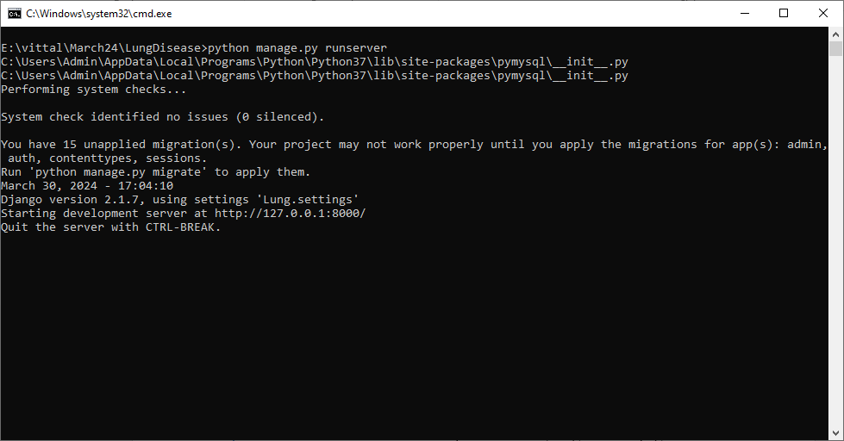

In above screen python server started and now open browser and enter URL as <http://127.0.0.1:8000/index.html> and press enter key to get below page

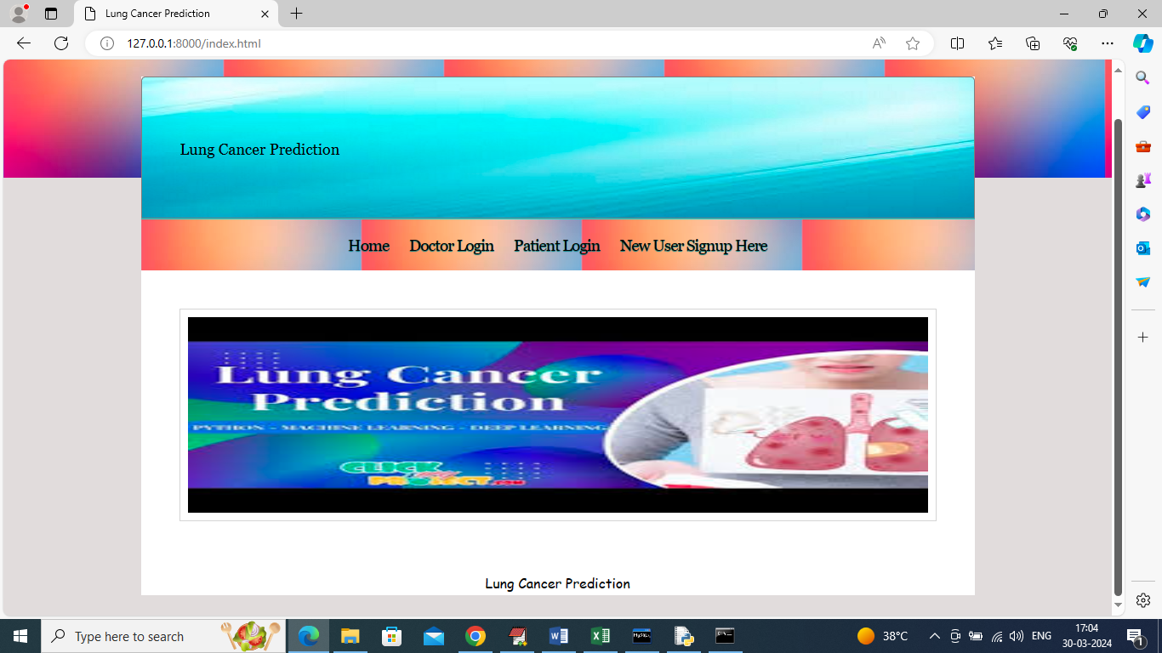

In above screen click on ‘New User Signup’ link to get below page

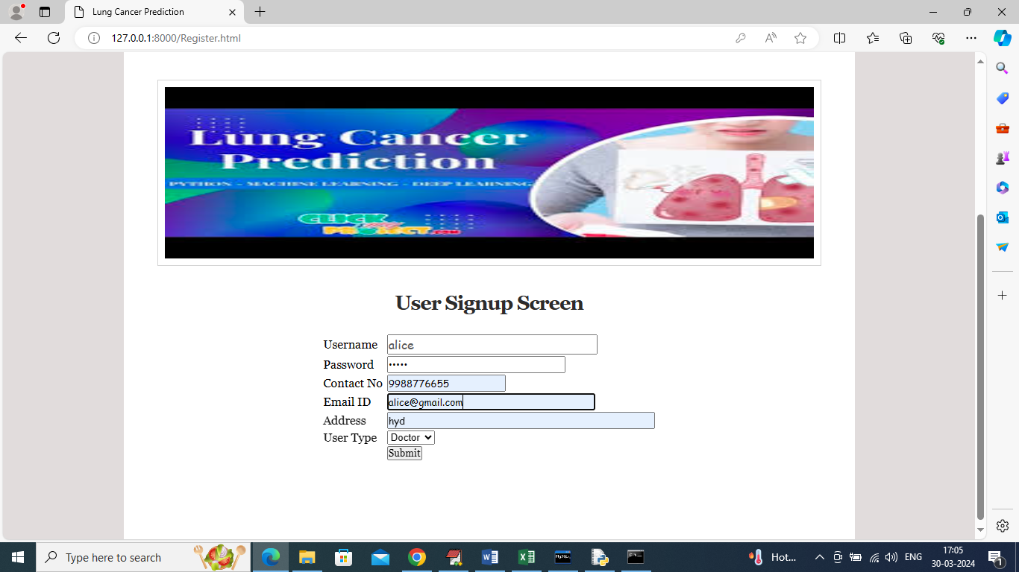

In above screen doctor is entering sign up details and then press button to get below page

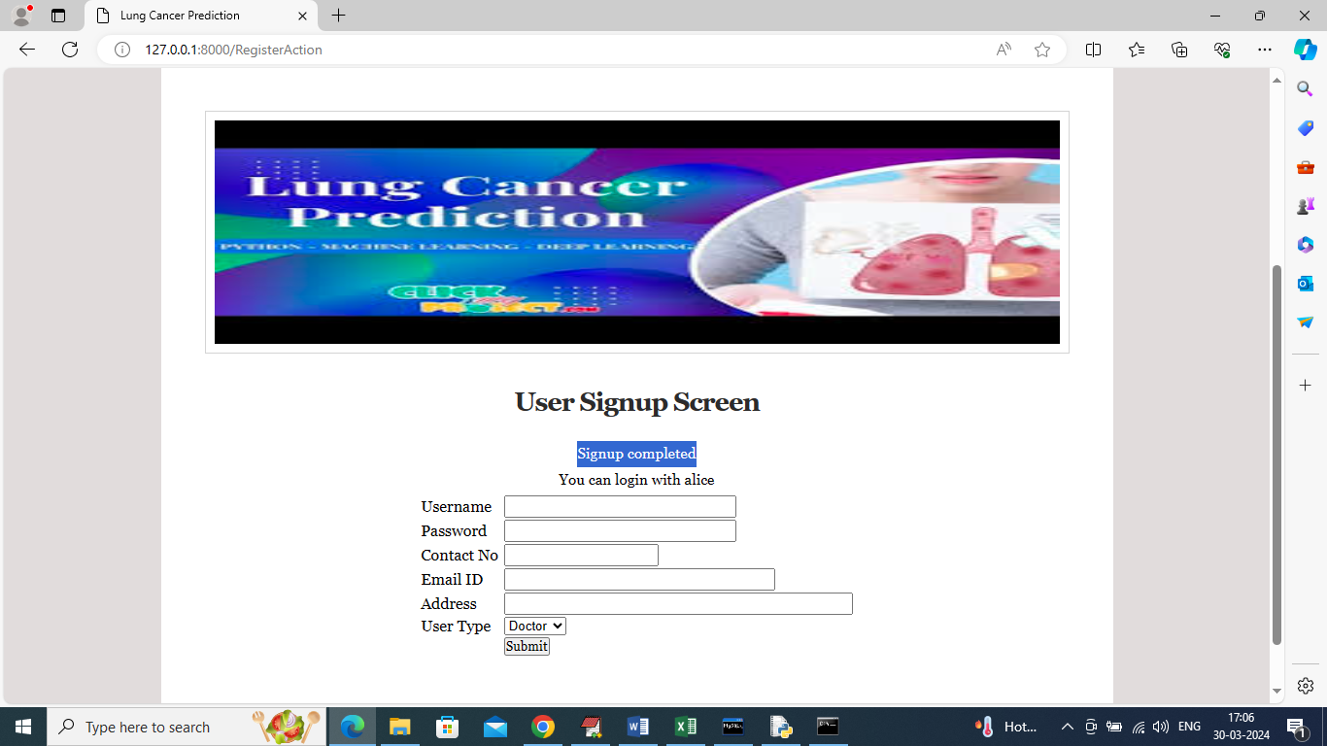

In above screen doctor sign up completed and similarly add patient details also like below screen

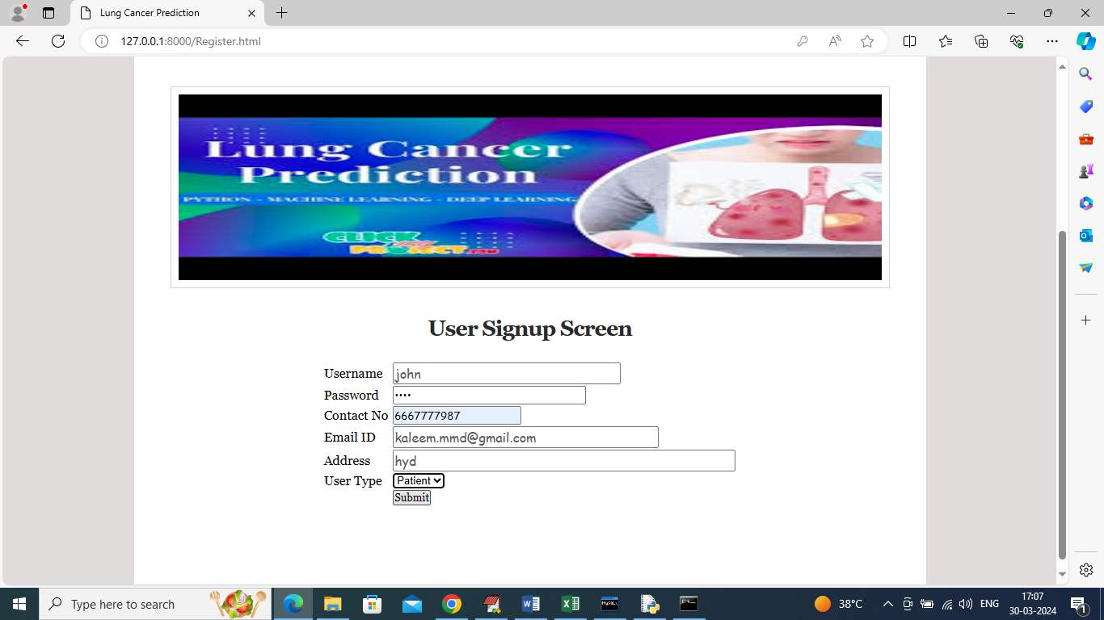

In above screen entering patient details and enter valid email to received OTP to emails and now click button to get below page

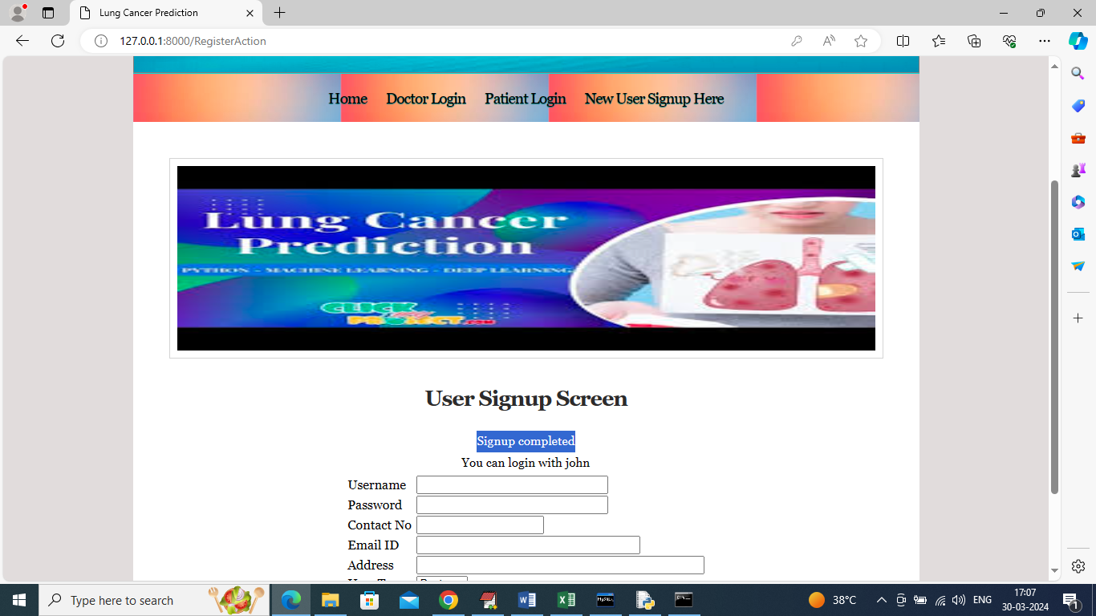

In above screen patient sign up completed and now click on ‘Patient Login’ link to login as patient

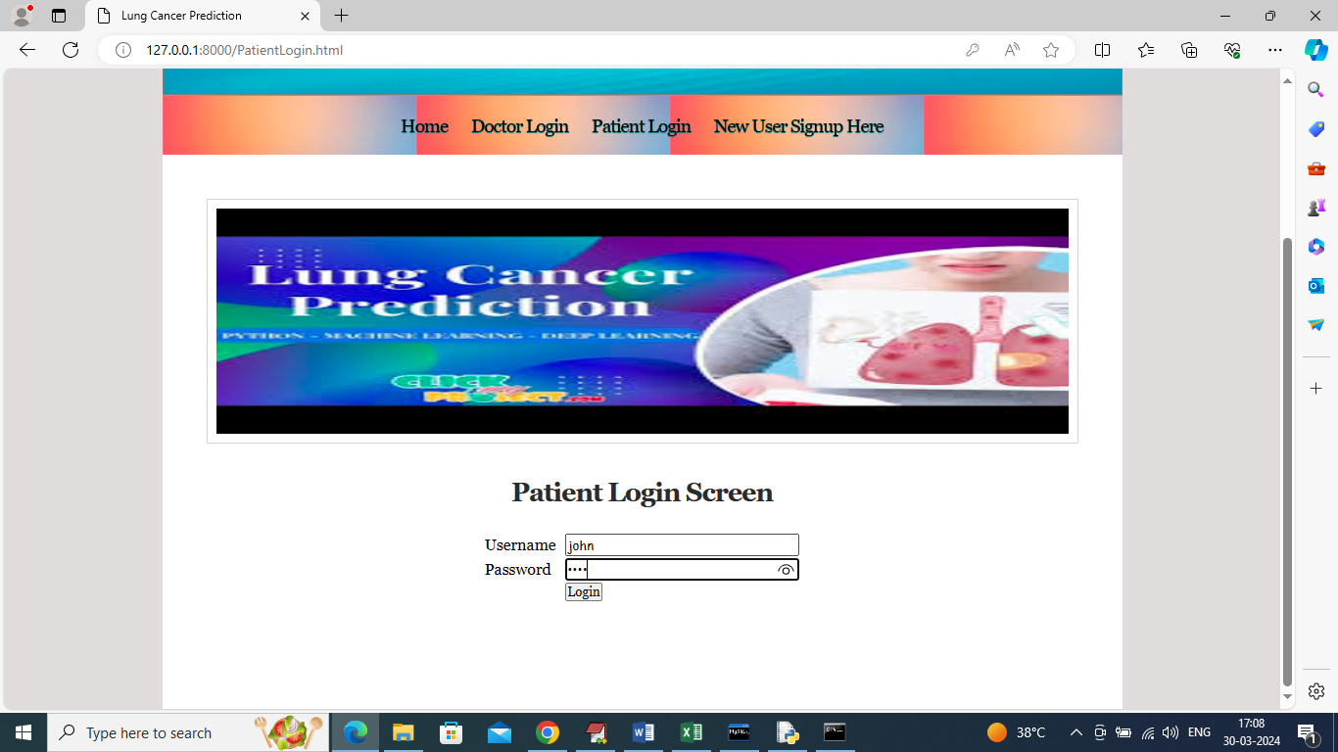

In above screen patient is login and after successful login will get below OTP page

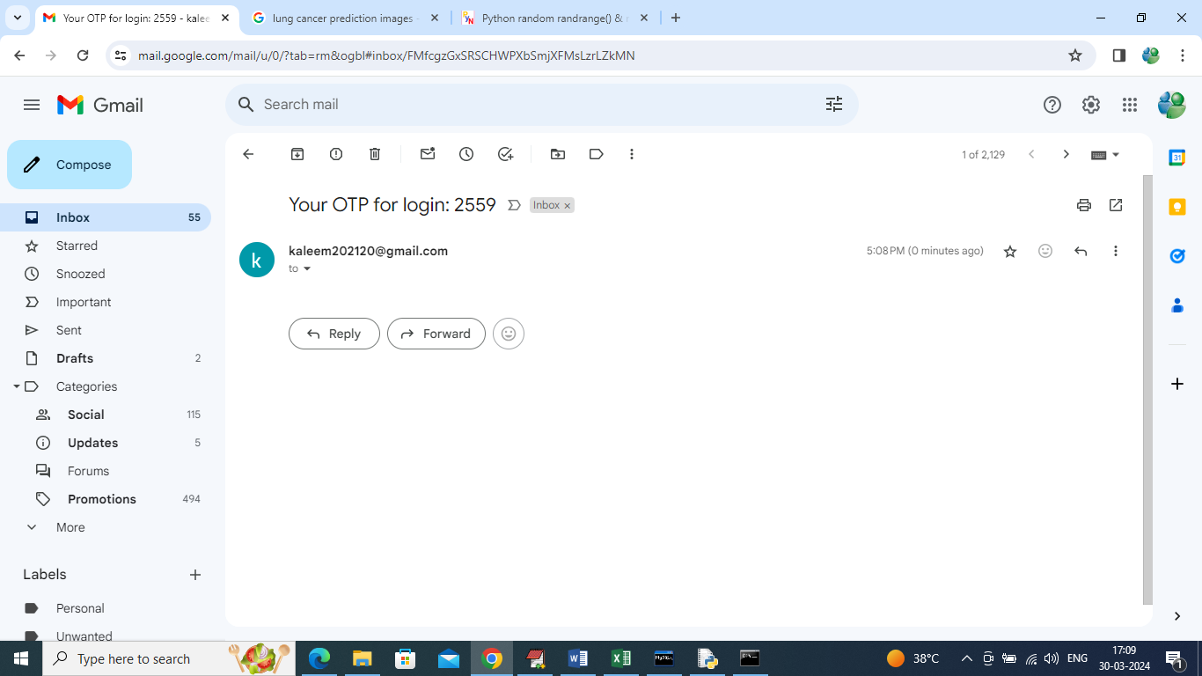

In above screen OTP received in email and now enter OTP in below screen to continue login

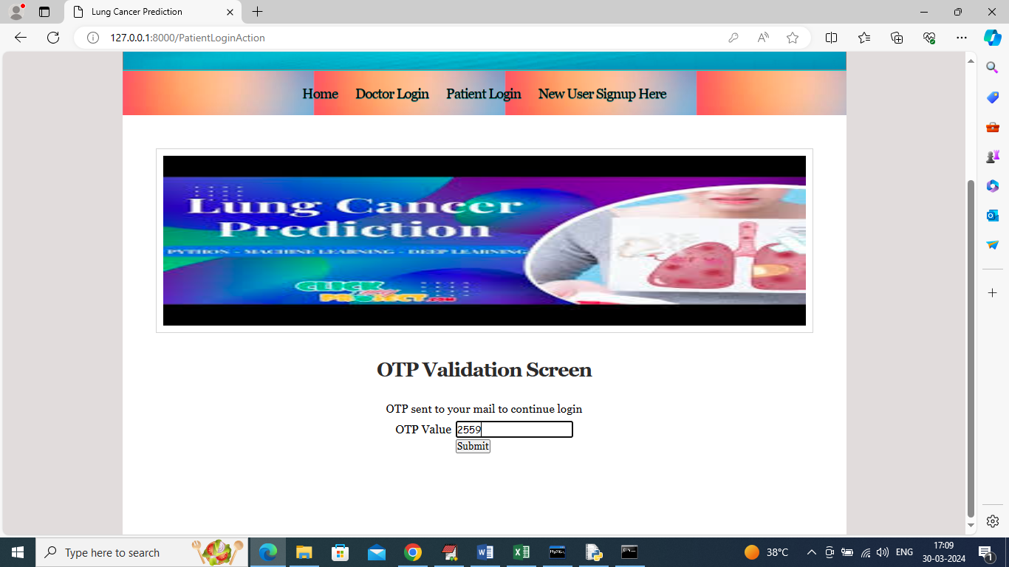

In above screen entering OTP values and then click on Submit button to get below page

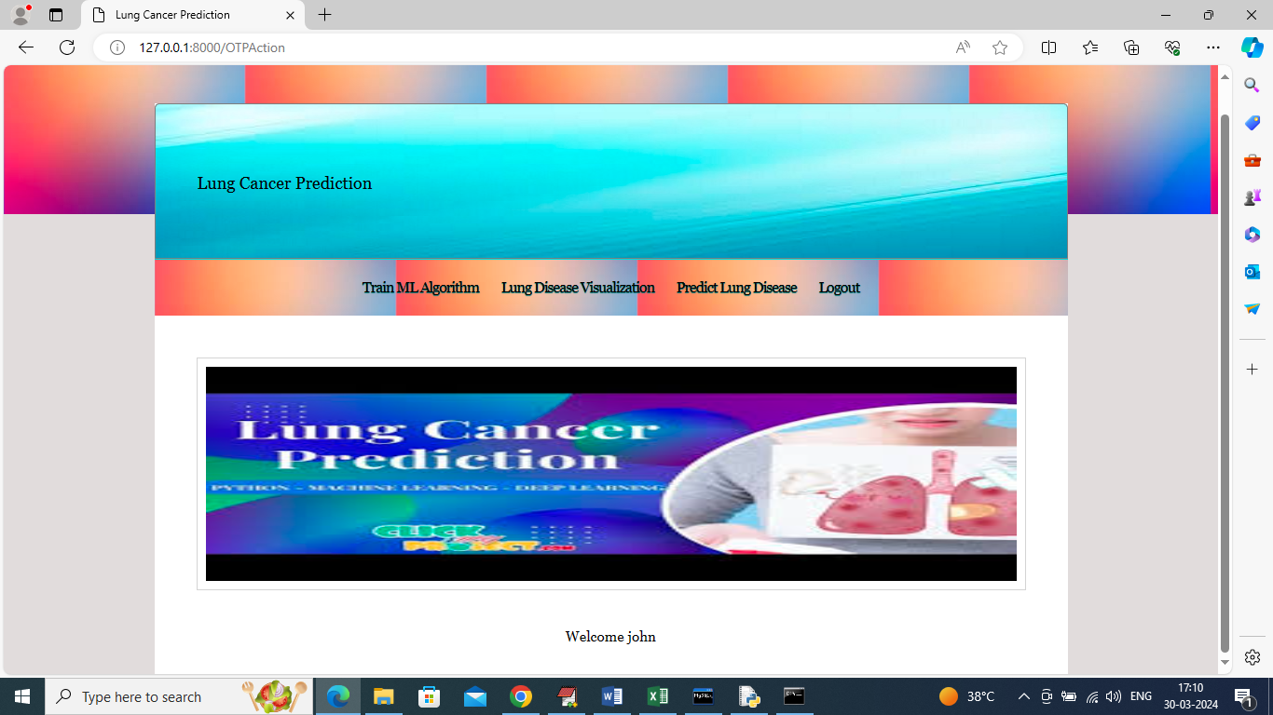

In above screen user can click on ‘Train ML Algorithm’ link to train ML algorithm and get below page

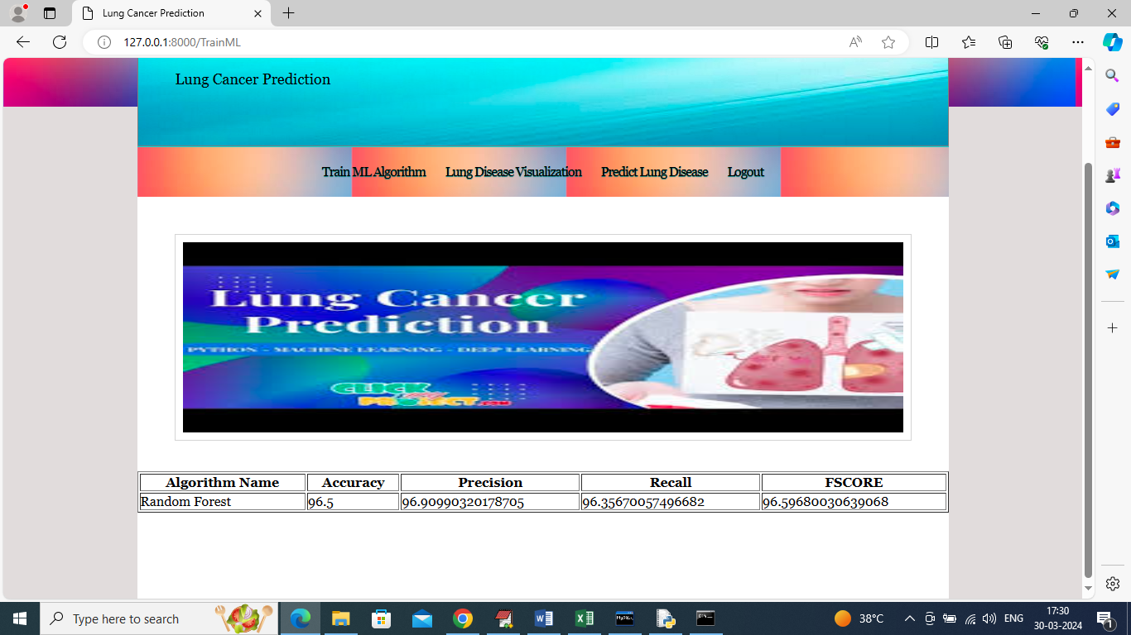

In above screen Random Forest training completed and it got 96% accuracy and can see other metrics like precision, recall and FSCORE and now click on ‘Lung Disease Visualization’ to analyze dataset to get various graphs

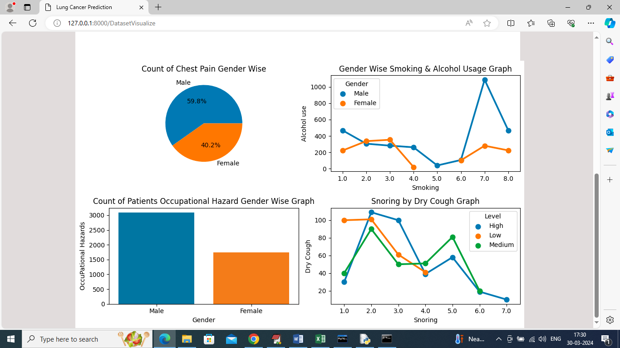

In above screen can see visualization using different attributes from dataset such as Gender, Hazard, chest Pain etc. Now click on ‘Predict Lung Disease’ link to get below page

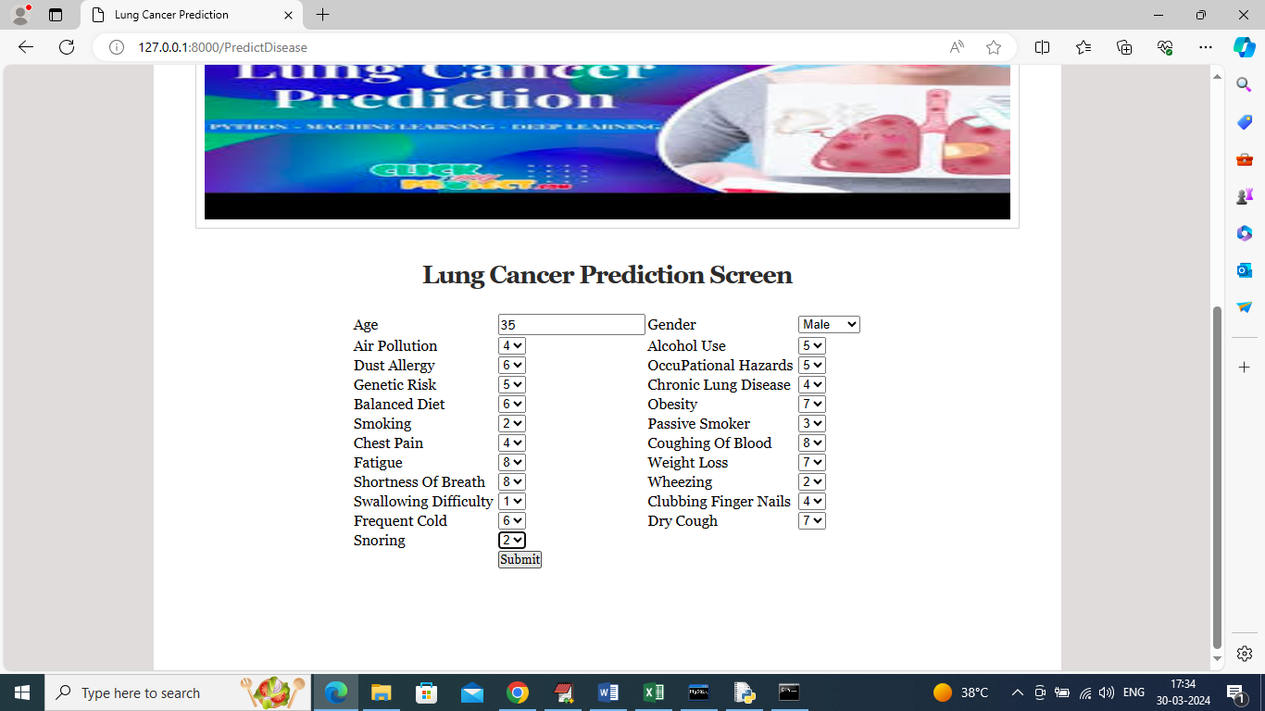

In above screen user will enter lung disease input values and then press button to get below predicted output

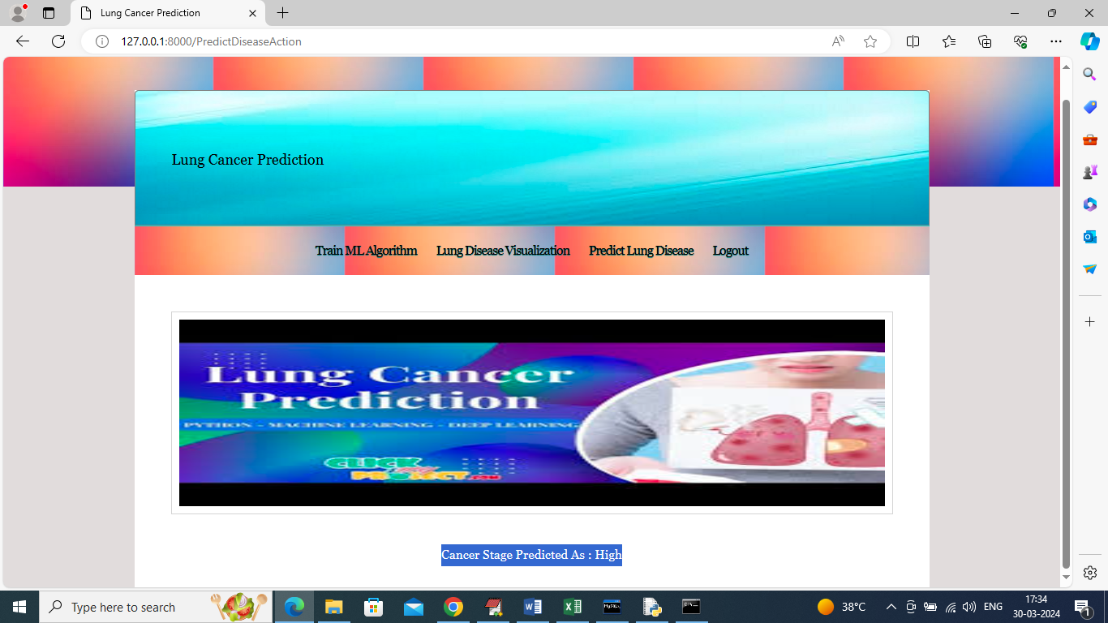

In above screen in blue color text can see disease stage predicted as ‘High’ based on input values and now logout and login as doctor to perform analysis

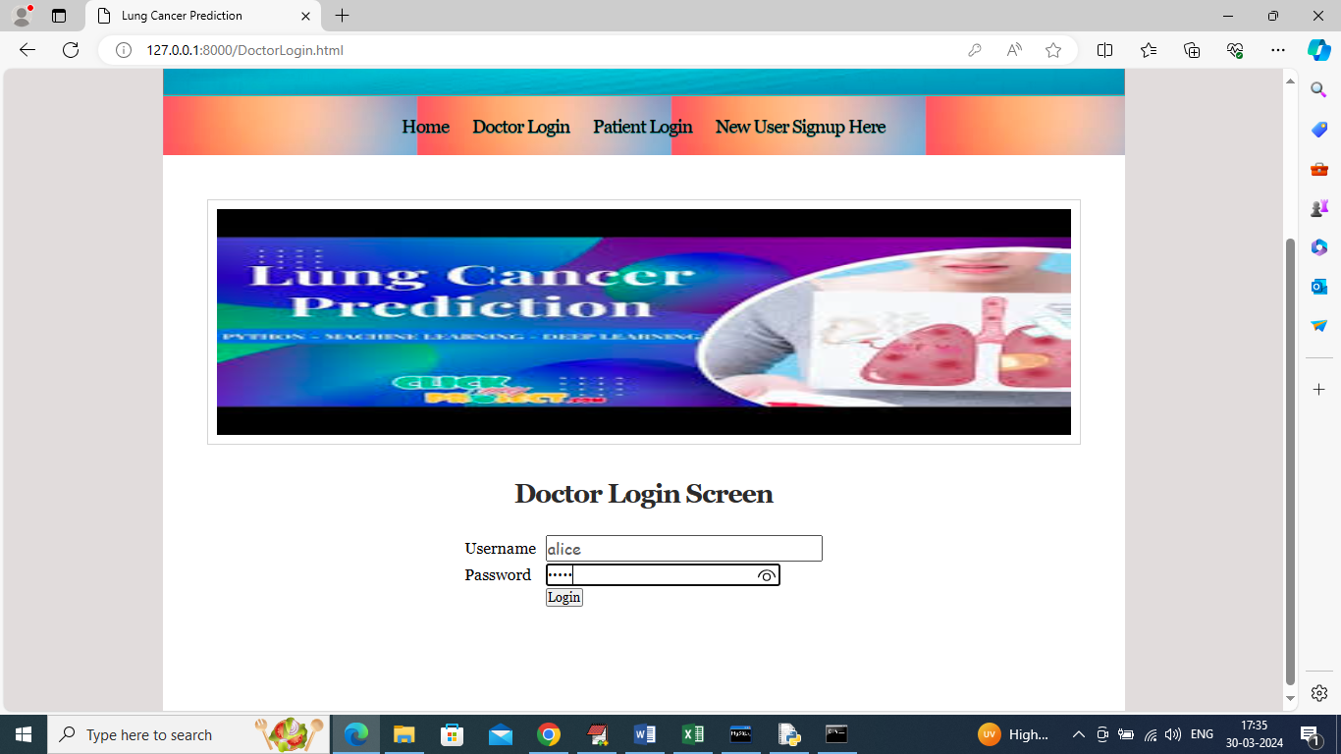

In above screen doctor is login and after login will get below page

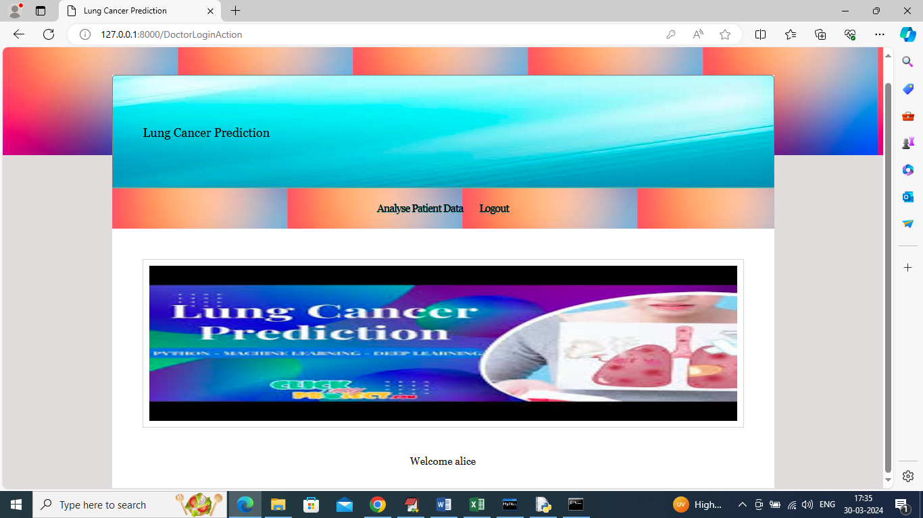

In above screen doctor can click on “Analyze Patient Data’ link to get below analysis report

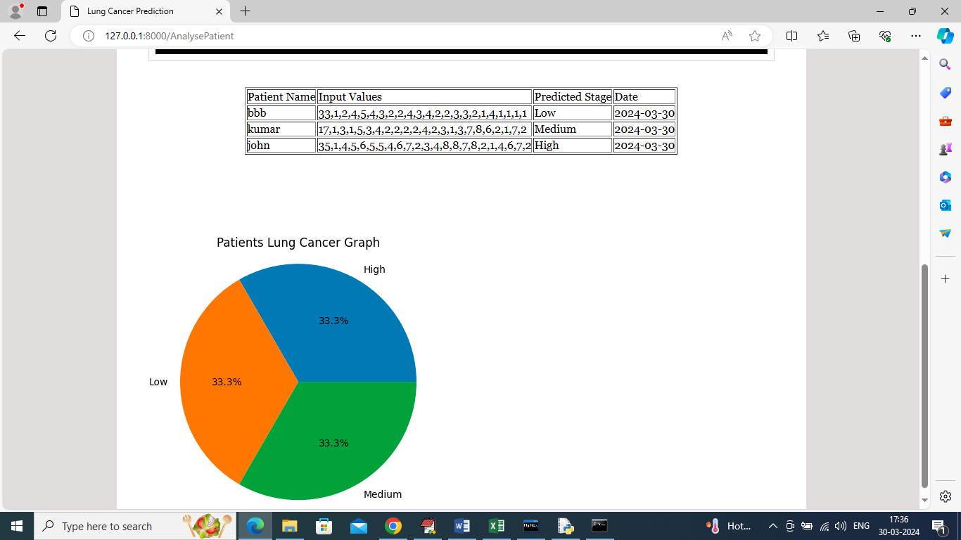

In above screen doctor can see different patients input data and then can see predicted lung cancer stage and in graph also can see number of patients suffering from different stage of cancer.

Similarly by following above screens you can predict lung cancer stage from given input values